

|  |  |
| --- | --- |
| **Student Name** | **Arun Adhikari** |
| **SRN No** | 202100406 |
| **Roll No** | 38 |
| **Program** | Computer Engg. |
| **Year** | Third Year |
| **Division** | G |
| **Subject** | CN |
| **Assignment No** | 4 |

**Assignment Number - 04**

**Title :** Conﬁguration of router by using router commands and implementation of static routing

**Problem Statement** Using a Network Simulator (e.g. packet tracer) Conﬁgure routers for static routing

### Theory :

**Router** – Router is a network device that allows you to direct data traﬃc to an appropriate destination.

Router maintain routing table that contain IP addresses of computers over the network. A router has

different components that enable proper functioning.

### Cisco IOS supports various command modes, among those followings are the main command modes.

* User EXEC Mode
* Privileged EXEC Mode
* Global Conﬁguration Mode
* Interface Conﬁguration Mode
* Sub Interface Conﬁguration Mode
* Setup Mode

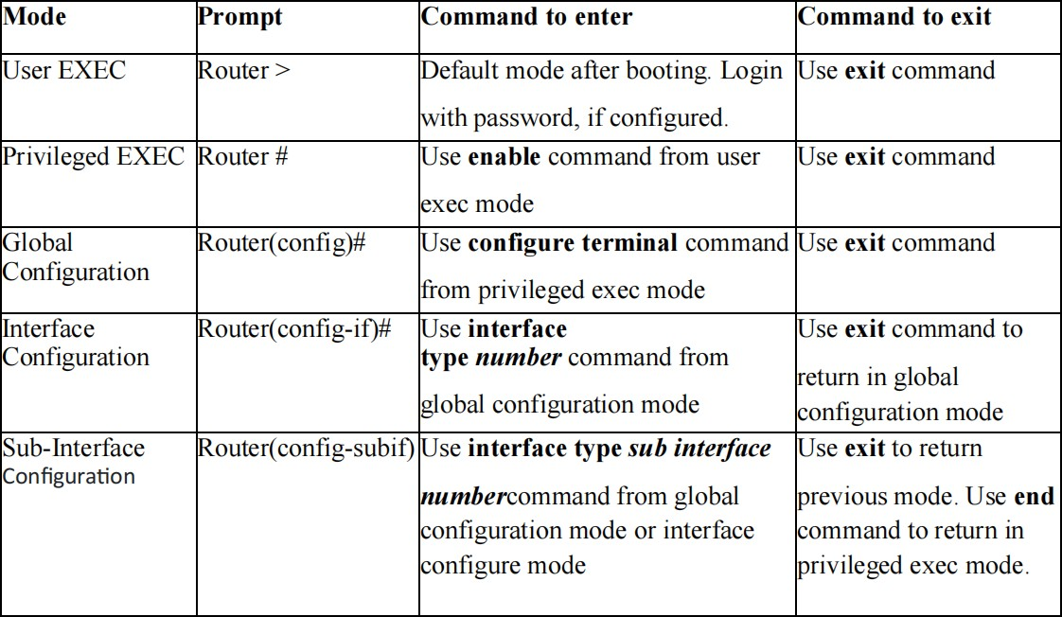

**Some important router Command**

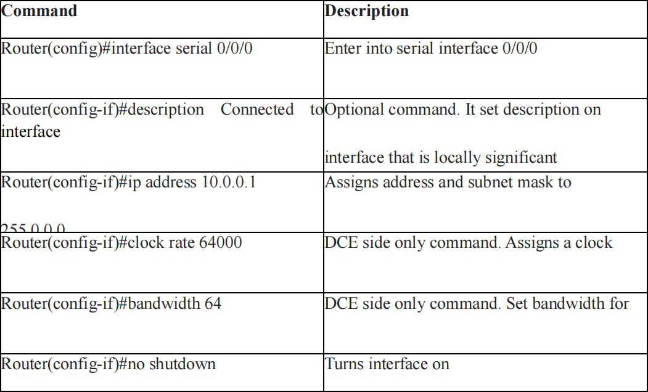

# Conﬁguration of static Routing

Screen shots of your implenetation

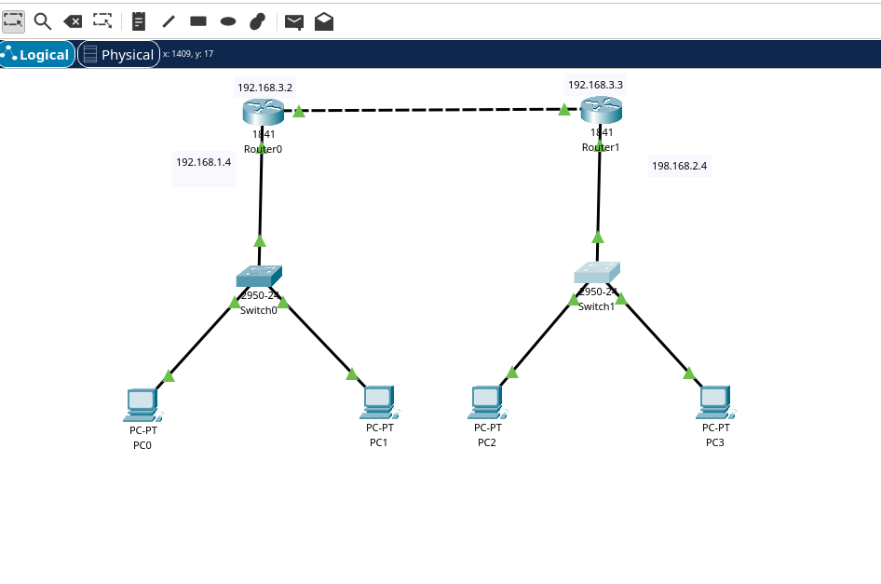

# Code

### Basic Router Conﬁguration – Static Routing Router0 Conﬁguration

STATIC ROUTING:

Router 1:

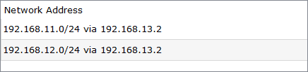

SERIAL IP ADDRESS:



FAST ETHERNET IP ADDRESS:



**Router1 Conﬁguration**

STATIC ROUTING:

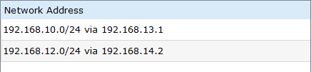

SERIAL IP ADDRESS:

Router 0 :



Router 2 :



FAST ETHERNET IP ADDRESS:

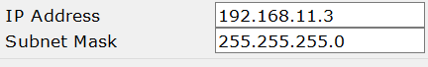

# Router2 Conﬁguration

## STATIC ROUTING:

Router 1:

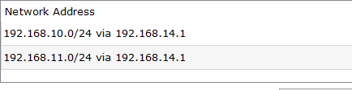

## SERIAL IP ADDRESS:

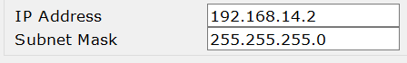

FAST ETHERNET IP ADDRESS:



# Conclusion:

## Static routing serves as a direct and eﬃcient approach for network administrators to manually set up routing tables within a network. It excels in its simplicity and predictability, especially in smaller and less complicated network environments. However, its practicality diminishes as network size and complexity increase. In such scenarios, dynamic routing protocols step in to offer automated and adaptable solutions. In simpler, well-managed setups where manual conﬁguration is favored, static routing remains a viable option.

## SERIAL IP ADDRESS:



FAST ETHERNET IP ADDRESS:



# Conclusion:

## Static routing serves as a direct and eﬃcient approach for network administrators to manually set up routing tables within a network. It excels in its simplicity and predictability, especially in smaller and less complicated network environments. However, its practicality diminishes as network size and complexity increase. In such scenarios, dynamic routing protocols step in to offer automated and adaptable solutions. In simpler, well-managed setups where manual conﬁguration is favored, static routing remains a viable option.